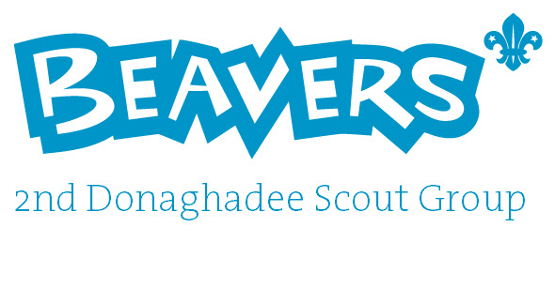

Welcome Pack

www.2nddonaghadee.scoutsites.org.uk

Facebook: 2nd Donaghadee Beaver Scouts (closed group)

Email: beavers2nddee@aol.com

Welcome to the 2nd Donaghadee Beaver Colony. This pack is designed to give you all the necessary information to get your child started in the Colony.
It includes:

- Information about Beaver Scouting and our Colony
- The Beaver Scout Promise and Motto
- Information about the awards and badges
- Information about the running of 2nd Donaghadee Scout Group
- Forms at the back to be completed and returned to Lesley Graham prior to your child joining (unless filled in @ registration night in September).

If you have further questions which are not answered here, then please
do not hesitate to contact one of the Beaver Colony Leaders as follows:

Lesley Graham E-mail - Beavers2nddee@aol.com
Beaver Scout Leader 07730457620

Stuart Graham Email - Beavers2nddee@aol.com
Assistant Beaver Scout Leader 07713437990

Christine Rankin
Assistant Beaver Scout Leader
(Group Scout Leader)

Paul McAlpine
Assistant Beaver Scout Leader

Our Colony Assistants:

Jill Constable
John Wallace

This booklet is intended to give you an overview of how the Colony works, what we expect of our Beavers and how you can help your child during their time with us. It should also answer some of the general questions which you may have.

If there is anything else you wish to discuss, feel free to speak to any of the Leaders after the Colony meetings (although that can get a bit hectic and may not be suitable if you need a quiet word). You could also contact one of the Leaders by email or phone, details can be found above.

Beaver Scouting and our Colony

The Aim of the Scout Association

The aim of the Scout Association is to encourage the physical, mental and spiritual development of young people so they may take a constructive place in society. We offer an enjoyable and attractive scheme of progressive training based upon a Beaver Scout Promise and Motto. All activities are guided by adult leadership.

The Beaver Scout Colony

The Beaver Scout Colony is run by our Beaver Scout Leaders with the help of our Colony Assistants and Young Leaders. All leaders are volunteers who give their time for free and receive special training for their role. The Leaders are responsible for planning and running a programme of activities and games at Colony meetings and special events. Colony meetings are held every Tuesday evening between 19.00 and 20.00.

The front doors of the church hall are locked at 19:10 and are reopened shortly before 20:00, this is for the safety of all our Beavers, if you are running late you can ring the bell and one of our Leaders will let you in.

The Beavers work in small groups called Lodges. The Lodges are identified by different colours – we have red lodge, green lodge and blue lodge and yellow lodge. Each lodge has a Lodge Leader and Assistant Lodge Leader who are generally older Beavers who can help the leaders and the younger Beavers in their lodge.

Capitation fee's and Subs

The Capitation fee is currently £35 per Beaver per year (this is reviewed annually), this goes to the Scout association and covers annual registration and insurance for your child. We attend our District's annual sponsored hike usually early October, any money raised for this can pay for part or all of the Capitation fees depending on how much raised. Capitation fees need to be paid by the end of October.
The subs equate to £2 per week, per Beaver and are payable at the start of each term, we plan each term and work out how many meetings are in the term which gives us our term subs fee. We will keep parents informed of the cost, this is then payable on the first night of each term, please place cash only in an envelope clearly marked with your child's name.
2nd Donaghadee Beavers do not have a Bank Account so unfortunately cannot accept cheques.
Activities and Awards

Beavers will enjoy a great deal of fun and adventure whilst in the Colony, which will lead to the award of badges to wear on their uniform. These are given in recognition of the effort made at their own level of understanding and development.
Each year some outdoor events and activities are undertaken e.g. Crate Climbing, Grass Sledging, Orienteering and Hikes, we also offer at least one Sleepover (usually not much sleeping done) for our Beavers to enjoy. We also attend various events put on by both the District and County teams.

The Uniform

Scouting is a uniformed organisation. Beavers are expected to wear full uniform for Colony meetings, parades and arriving and departing from events.

For weekly meetings/outings

- Beavers sweatshirt (essential item)
- Beavers polo shirt (optional item) or a white polo shirt
- Scout Activity trousers (optional item)
- Navy jogging bottoms
- Beavers baseball cap (optional item)

For formal occasions e.g. St George's day Parade, Church Services

- Beavers sweatshirt (essential item)
- Beavers polo shirt (optional item) or a white polo shirt
- Scout Activity trousers (optional item)
- For boys school trousers (black or grey) and school shoes
- For girls school trousers/skirt (black or grey only) and school shoes, any hair bands/bobbles should be plain navy.

Please note that uniform including scarf, woggle must be worn at all meetings/outings unless informed otherwise in advance.

ALL ITEMS OF UNIFORM, INCLUDING SCARVES, SHOULD BE CLEARLY MARKED WITH YOUR CHILD’S NAME.

Scarves, woggles and badges will be provided as appropriate by the Scout Group initially. Any scarves, woggles or badges lost, will have to be replaced at parents expense.

If you have difficulty rolling a scarf please ask one of the leaders to show you.

Uniforms can be purchased at any of the following:
Online at the Official Scout Shop  www.shop.scouts.org.uk  all the official uniform can be bought here as well as other fun stuff for Beavers!! | Scout Shop (Belfast)  12-14 College Square East  Belfast  BT1 6DD  Telephone - 02890320580  www.discoveroutdoors.uk.com | Roberts of Bangor,  24, Central Avenue,  Bangor,  County Down.  BT20 3AF  Telephone - 028 9127 0516  Mon - Sat 9:30 - 5:30

We expect a high standard of appearance and this is subject to an inspection each week contributing to ‘Lodge of the Month’. The winning Lodge is awarded a prize at the end of each month. Please encourage your child to take a pride in this.

The Beaver Scout Log Book

Each Beaver will be given a Logbook at their Investiture, it takes its readers on a journey along the riverbank, the Logbook is the perfect companion for every Beaver Scout.

On the way they find out:
- how to become a Beaver Scout
- what badges they can earn
- what activities to try

Full of games and puzzles and with plenty of space to write and draw, the book is designed for the early reader. Beautifully illustrated throughout, the Logbook will be read and enjoyed over and over again.

Investiture

Once a beaver has attended a minimum of 6 weeks they will be invested into the Scout Movement. After they have said their Promise, they will receive their scarf and Group name tape, Ulster Badge, County Badge, District Badge and World Badge.

The Promise is as follows:

I promise to do my best
To be kind and helpful
And to love God.

The Beaver Scout Motto is:

Be Prepared

Please note: If moving up from squirrels the Beaver will say their promise and receive their World Badge, but they will continue to use the scarf issued in squirrels and the Group name tape, Ulster Badge, County Badge, District Badge should be transferred from their squirrels jumper. Scarf and badges listed above will not be re-issued.

Looking after your children
Most adults in Scouting, including all the leaders at the 2nd Donaghadee Scout Group, are volunteers. The Scout Association has a thorough training programme that all leaders have to participate in. They must also undergo a full Access NI check, supply personal references and be approved by the Adult Appointments Committee before their first appointment.

All appointments are then subject to regular review and renewal.
Leaders also have regular First Aid training and, of course, we do our best to ensure that no Beaver is injured. However, with up to 28 young, energetic, enthusiastic and active children in a confined space, parents should be aware that there is always the possibility of an accident.

In addition to the adult leaders, from time to time we have invaluable assistance from Young Leaders. Young Leaders are Explorer Scouts from one of the more senior sections who also volunteer to help out.

Clearly the safety of everyone involved in Scouting is our primary concern at all times and we have strict guidelines for the ratio of adults to Beavers.
There may be times when we need parental help to make sure that we meet these supervision requirements, such as if an existing leader is unable to attend a meeting, or if the nature of the activity is such that more adult supervision is required to ensure the Beavers’ safety.

Due to the shortage of places available and the number of children waiting to join Beavers, we ask that Beavers attend meetings regularly.
We do understand that there may be valid reasons for non-attendance, but in the absence of an adequate explanation, Beavers not attending for four weeks in a row, or for more than half of any term will trigger a review of their on-going membership which may result in their place being taken away. We will always give parents an opportunity to explain the reason for non-attendance prior to arriving at this conclusion.

Photography

From time to time, we may take photographs of the Beavers during Colony meetings or outings, some of which will be added to our Scout Group Facebook page/web site where you can keep up to date and see how much fun we have in all the sections.
If you have any objections to your child being included in these photographs, please inform a Leader in writing in advance so that we can ensure we comply with your wishes.

Beavers Behaviour and Conduct

All Beavers are expected to be polite, considerate and respectful to others, take turns, share, play fairly, be quiet when others are speaking and take care of equipment.

Fighting, kicking, shouting, teasing, bad language, hitting, pushing and bullying are not acceptable and this sort of behaviour will not be tolerated. We encourage all Beavers to report this behaviour when it occurs.

Minor incidents will be discussed with the Beaver directly and may result in a ‘time out’ during a game or activity if appropriate. More serious or repeated incidents will result in the Beaver’s parents being contacted and you could be asked to collect your child from the meeting or sleepover. We want all of our Beavers to enjoy their time with us to the full – but not at the expense of others in the Colony.

The support of parents is very much appreciated in enabling us to correct unacceptable behaviour, but we do ultimately reserve the right to suspend or remove the Beaver from the Colony if opportunities to improve are not taken or the incident is serious enough.
The Awards and Badges

Badges are paid for from Colony funds – all that we would ask is that they are sewn on promptly so that the Beaver can display them proudly and they do not get lost.

There may be times when some work towards these badges needs to be completed at home. If this is the case, please encourage your child to complete the work – but don’t do it for them. The emphasis is very much on each Beaver taking part to the best of their ability – there are few absolute standards that have to be reached.

The Six Challenges

There are six separate challenge badges a Beaver can earn, each having their own relevant choices of activity.

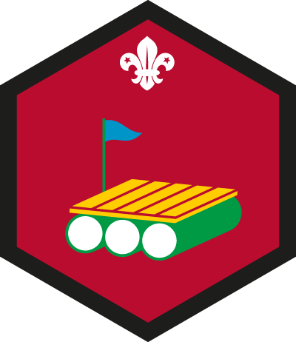
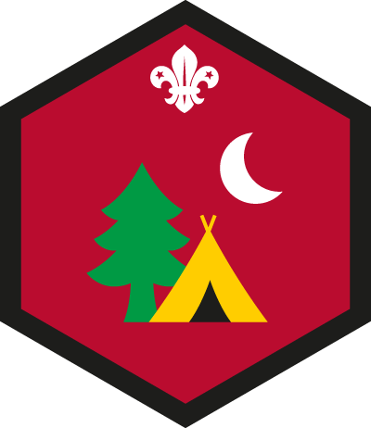





My Adventure My Outdoors Personal My Skills Teamwork My World
Challenge Challenge Challenge Challenge Challenge Challenge

The Chief Scout’s Bronze Award



The Chief Scouts’ Award runs through all sections of the movement. This is the highest award in the Beaver Section.

To complete this award a Beaver must have completed the above six challenges.

If a Beaver Scout has not quite completed the requirements
for the top award when they move on to the Cub Scout Pack, they may complete them in their first few weeks in the Cub Scout Pack.

Activity Badges

There are 18 Activity Badges a Beaver can earn (examples below) with a wide range of subjects available, each having their own laid down requirements. Some can be done within the Colony and some individually.


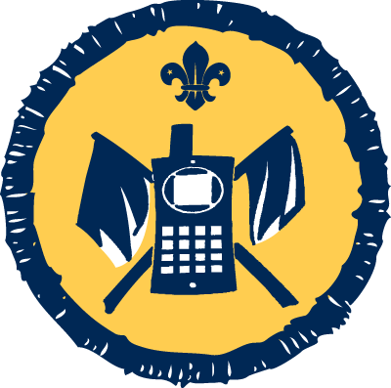

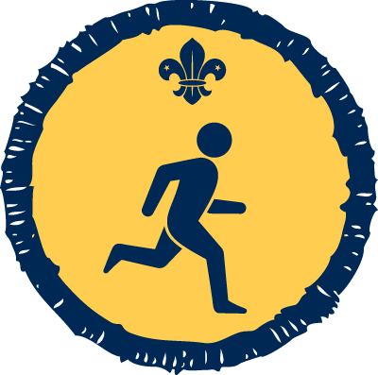

Sports Space Communicator Chef Camp Craft

Staged Activity Badges

The Staged Activity Badges have been designed to provide a unified approach throughout the Sections. All the Staged Activity Badges have 5 stages, except Nights Away - which has 12 and Hikes Away, which has six. This means that a young person can gain whichever badge is appropriate to the level they have reached. It is possible, for example, for a Beaver Scout who is an excellent swimmer to gain a higher level badge than a Cub Scout who has just taken up the activity. (examples below)


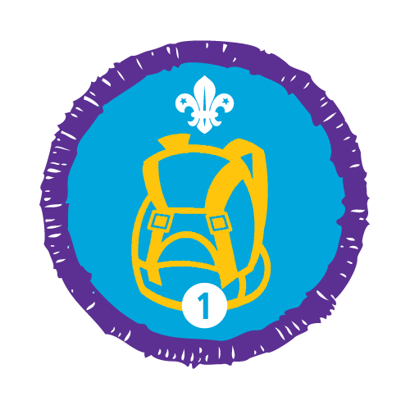
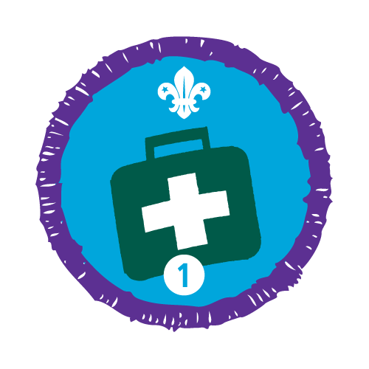

Emergency First Aid Hikes Away Navigator Nights Away

The Beaver Scout Moving On Award

This award is intended to help a Beaver make a smooth transition into the Cub Pack.



2nd Donaghadee Scout Group

The 2nd Donaghadee Scout Group is currently made up of five sections: The Squirrel Drey, The Beaver Colony, The Cub Pack and The Scout Troop and Explorer Scouts.

Squirrels: Age 4-6 years (boys and girls) Tuesday 18:00 – 19:00

Beavers: Age 6-8 years (boys and girls) Tuesday 19:00 – 20:00

Cubs: Age 8-10.5 years (boys and girls) Wednesday 18:45 – 20:15

Scouts: Age 10.5-14.5 years (boys and girls) Wednesday 20:00 – 21:30

Explorer Scouts: Age 14.5-18 years (boys and girls) Monday

Parental Help

Your child will gain much more from Scouting if you are prepared to offer your support.

There are many ways you can help:

- Offer a skill or hobby to train or test the Beavers for badge or award work.
- Help with Colony or Group events.
- Help transport Beavers and equipment to events outside the village, such as camps.
- Join the Scout Group Executive to support the Group through fundraising for new equipment, leader training etc.

Or how about taking an active role in one of the sections either as a regular helper or as a full time warranted leader? If this interests you then please discuss this further with any leader. All help is valued and no experience is necessarily needed. Full support and training can be arranged.



POSITION OF BADGES ON THE BEAVER UNIFORM

It is the policy of The Scout Association to safeguard the welfare of all
members by protecting them from physical, sexual and emotional harm.
The following is an excerpt from the Association’s “Yellow Card” – a Code of
good practice for Adults in Scouting which all leaders must follow.

Young Person’s Information
Surname: |  | Forenames:
Address:

Post Code: | D.O.B: / / |  | Gender:
Telephone: |  | Mobile:
Email Address:
Religion: |  | School:

Name of Doctor:
Practice Address:

Post Code: | Practice Telephone:

Have they been immunised against tetanus? YES / NO Date: / /

For the following questions, please continue on additional sheet if needed:
Do they suffer from any of the following (please specify):-

Asthma | YES / NO
Diabetes | YES / NO
Nervous Disorders | YES / NO
Hay Fever | YES / NO
Migraine | YES / NO
Chest Complaints | YES / NO
Fits / Faints | YES / NO
Other | YES / NO

Do they have any allergies (please specify): -
Antibiotics | YES / NO
Food Colouring | YES / NO
Medicines | YES / NO
Food | YES / NO
‘E’ Numbers | YES / NO
Other | YES / NO

Are they receiving any medical treatment at present (please specify):
YES / NO

Do they carry medication on them at all times (please specify):
YES / NO

Emergency Information – In an Emergency we can contact:

Contact One

Name: | Relation:
Telephone: | Mobile:

Contact Two

Name: | Relation:
Telephone: | Mobile:

Membership /Medical Form
Parent’s Information

First Name: |  | Surname:
Address (If different from above):

Print Name: | Signed: |  | Date: / /

Should an emergency arise, we need your written permission to seek medical advice or administer
treatment/first aid/medicine to your child. If you consent to this please sign below:
Print Name: | Signed: | Date: / /

‘I accept that the Scout Group will be keeping information about my son/daughter’s membership of the Scout Movement for Scouting Purposes, I also give explicit consent to the holding of information about my son/daughter’s health and disabilities for Scouting Purposes.’

Print Name: | Signed: | Date: / /

s – 01733 897790 / 07961063434
As part of the Beaver Scout programme, we may participate in activities outside of our normal meeting place; we may take photos of the Beavers during activities for the use of the 2nd Donaghadee Scout Group as well as for wider community use. Please complete the form below to give permission for the named young person to participate in the following activities during their time with the 2nd Donaghadee Beaver Colony. We will seek further permission for any trips or activities outside of the permission granted on this form.

Young Person’s Name:
 | Agree | Disagree
I give permission for the named young person to take part in
activities around the local area (around Donaghadee)

I give permission for the named young person to have their photo taken for use within the 2nd Donaghadee Scout Group.

I give permission for the named young person to have their photo taken for the 2nd Donaghadee Web site and Facebook page.

I give permission for the named young person to have their photo taken for wider community use e.g. for local paper (Chronicle)

I give permission for the named young person to receive basic first aid when needed, including the use of plasters.

I would be happy to receive letters and information via email from 2nd Donaghadee Beaver Colony and not have a paper copy.
(please ensure you have included your email address on previous page)

Signed: ___________________________________________ Date:______________

A Gift Aid Donation towards the Running Costs and Membership of the
below information.

Name of Charity: 2nd Donaghadee Scout Group
Title:
Surname:
Forenames:
Address:

Post Code: | Date: / /
Print Name:
Signed:
Young Person Name:

You must pay an amount of Income Tax and/or Capital Gains Tax for each tax year (6 April one year to 5 April the next) that is at least equal to the tax that the charity will reclaim on your gifts for that tax year.

Please notify 2nd Donaghadee Scout Group if you:
- Want to cancel this declaration
- Change your name or home address
- No longer pay sufficient tax on your income and/or capital gains.

Tax claimed by the charity
- The charity will reclaim 28p of tax on every £1 you gave up to 5 April 2008
- The charity will reclaim 25p of tax on every £1 you given on or after 6 April 2008
- The government will pay to the charity an additional 3p on every £1 you give between 6 April 2008 and 5 April 2011. This transitional relief for the charity does not affect your personal tax position.

If you pay income tax at the higher rate, you must include all your Gift Aid donations on you Self Assessment tax return if you want to receive the additional tax relief due to you.

